Speaking Task 1

**Agree/Disagree**

I agree or disagree with the idea that ______ for two main reasons.

The first reason is that ______

The second reason is that ______

Overall, I think ______

**Preferences**

I prefer ____(X) to/over ____(Y)

First of all ___

Secondly ___

Overall, I think ___

**Three Choices**

This is a good/great question. If I had to choose, I would choose ______

First of all ___

Secondly ___

Overall, I think ___

**Advantage and Disadvantage**

There are certainly benefits and drawbacks of ______

One advantage is that ______

On the flip side (However), a major disadvantage is that ______

Speaking Task 2

| **Agree** | **Disagree** |
| --- | --- |
| The man/woman agrees with the announcement/letter/article, which is about  There are two reasons why the man/woman supports the announcement/letter/article  One reason is that  Another reason is that  Therefore, these reasons are why the man/woman believes that ... is a good idea. | The man/woman disagrees with the announcement/letter/article, which is about  There are two reasons why the man/woman opposes the announcement/letter/article  One reason is that  Another reason is that  Therefore, these reasons are why the man/woman believes that ... is not a good idea. |

Speaking Task 3

Note that the X here stands for the concept we are talking about, so for the sample this would be "clinal variation"

From the reading passage, X is described as __________

The professor further illustrates/demonstrates/delves into this subject by giving one/two examples.

Firstly, __________

Secondly, __________

(Optional) In summary/So/Therefore, __________

Speaking Task 4

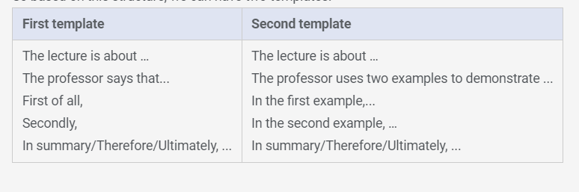

Writing Task 1

The reading and the lecture are both about __.

Whereas the author of the reading states that __, the lecturer suggests that __

The lecturer casts doubts on the main points made in the reading by providing two/three reasons.

First of all, according to the reading, ..... .However, the lecturer disputes this point.

He says that …..

(Optional) Furthermore, he/she mentions that ….

Secondly, the reading states that …. .Nevertheless, the lecturer refutes this argument.

He/She argues that …

(Optional) In addition, he/she points out ...

Finally, the reading claims that … .On the other hand, the lecturer believes that …

He/She thinks that …

(Optional) Moreover, he/she feels that …

In conclusion, although the reading and the lecture are both about __, the two/three main points made in the reading are effectively challenged by the lecturer.

Writing Task 2

1.The topic of ___ has generated much discussion in recent years.

2. My personal belief is ___

For example,

3. I understand ___ concern over ___,

but I believe he misses another critical point.

I totally agree with ___ point about ___, and I would like to add ___

4. (restated reason) ___, which is why I believe ___ (restated main point)